7.28: a) From (0, 0) to (0, L), 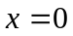 and so 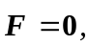, and the work is zero. From (0, L) to (L, L), 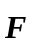 and 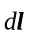 are perpendicular, so 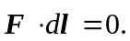 and the net work along this path is zero. b) From (0, 0) to (L, 0), From (L, 0) to (L, L), the work is that found in the example, 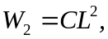 so the total work along the path is 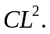 c) Along the diagonal path, 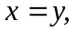 and so 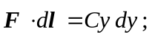 integrating from 0 to L gives 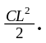 (It is not a coincidence that this is the average to the answers to parts (a) and (b).) d) The work depends on path, and the field is not conservative.

